|  |  |  |
| --- | --- | --- |
| **Supervisor** | SIR MUHAMMAD HARIS | |
| **Batch** | 2401G3 | |
| **Group** | **C** | |
| **Serial No.** | **Enrollment Number** | **Student Name** |
| 1. | Student1547443 | MISS AYESHA NAZ |
| 2. | Student1551007 | MR. MUHAMMAD AYAAN MEHFOOZ |
| 3. | Student 1546909 | MR. MUHAMMAD HAMMAD SHAHID |
| 4. | Student1549513 | MISS MALIHA TAHIR |

# Navbar:

Using the navbar, the user can navigate through various categories. We have total 7 items in Navbar, which are further classified as:

* HOME
* BRANDS
* CATEGORIES
* COMPARE
* ABOUT
* CONTACT
* LOG IN/SIGNUP
* **Destinations Page**: Includes 6 top travel destinations (Paris, Bali, New York, Tokyo, Sydney, Cape Town).
* **Categories Page**: Features 6 more travel categories/pages.
* **Packages Slider**: Showcases our travel collections and their categories.
* **Navbar**: Contains sections about our company, services, account, and our travel categories.



# Home Page:

# 

**Categories**

We have a total 3 categories.

**Gallery**

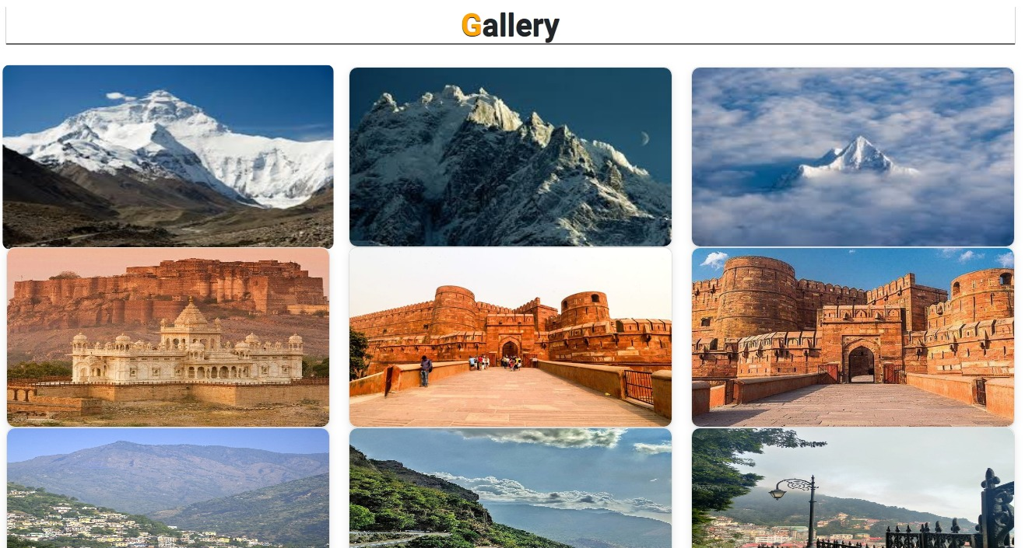

**Fort**

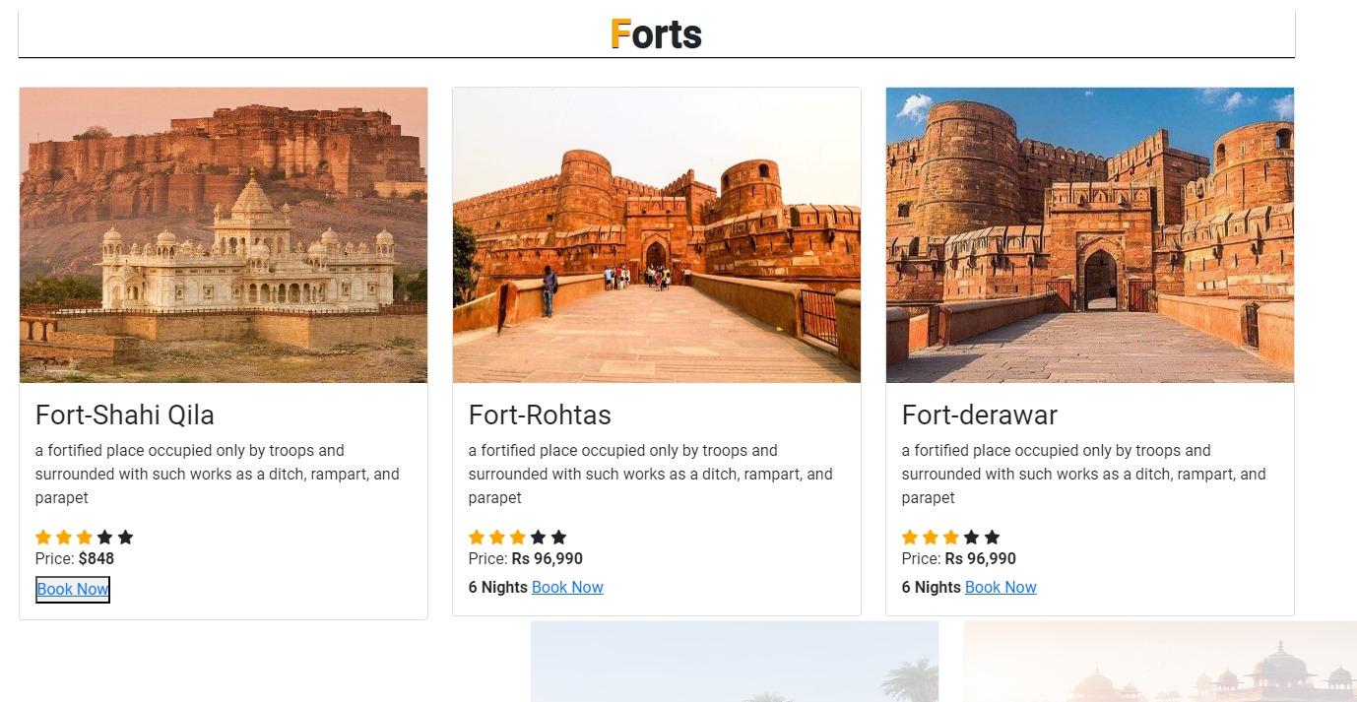

**Mountains**

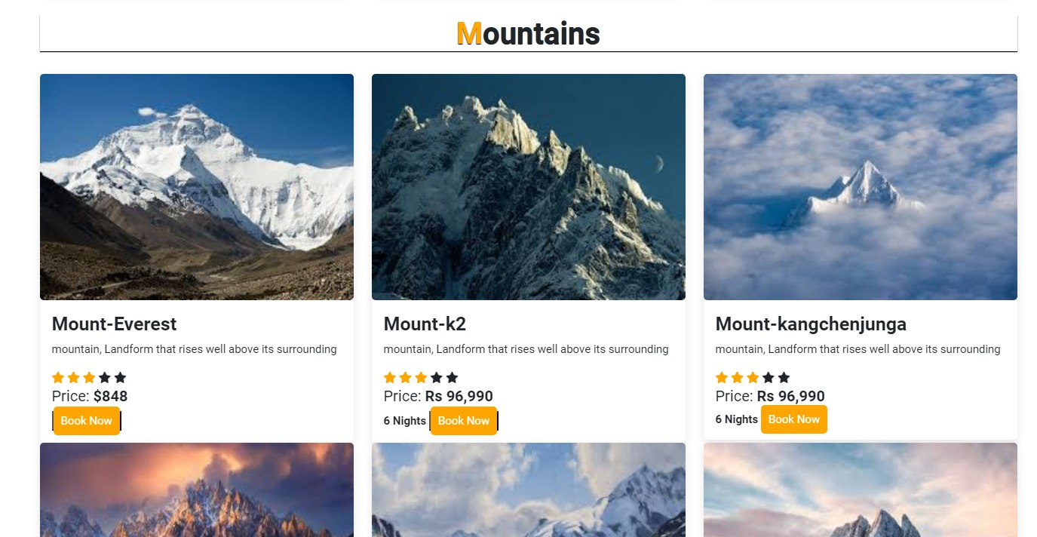

**About Us Page:**

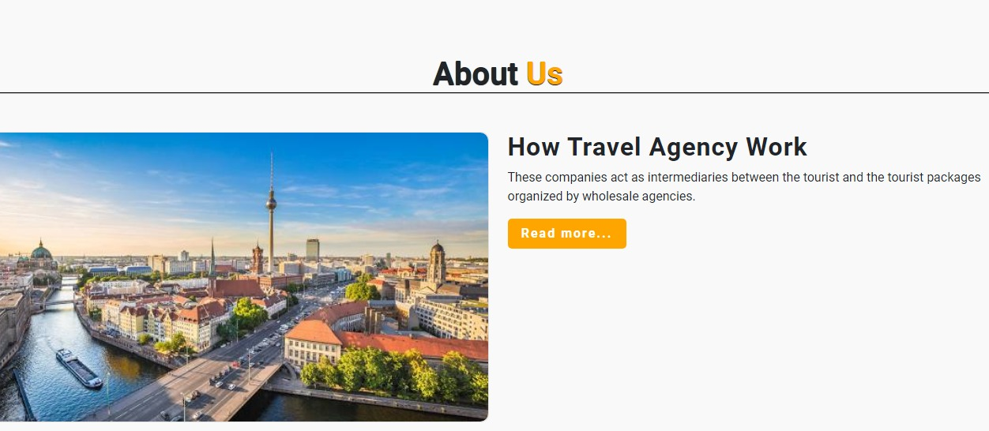

**Footer Page:**





**Contact Us Page:**

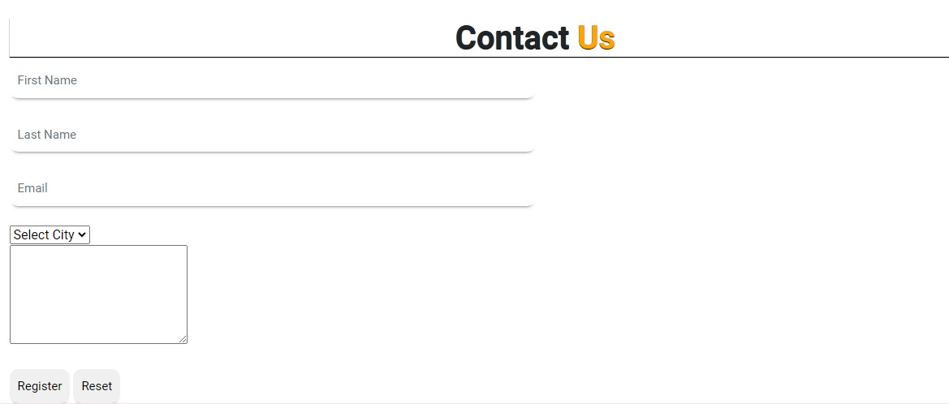

**Location:**

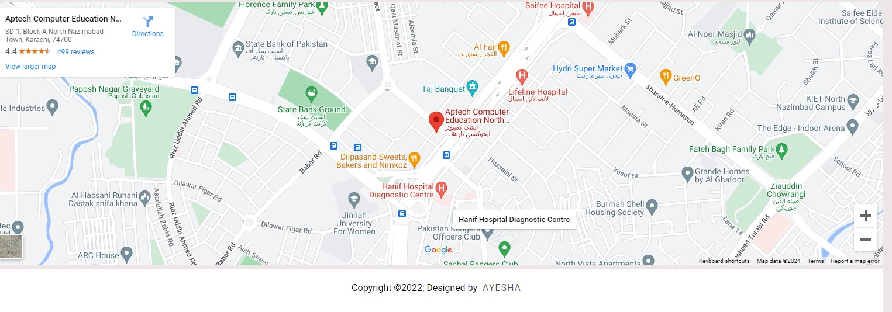

**Summary:**

**Categories and Styles:**

**Travel packages offer a range of styles, destinations, and experiences.**

We help customers find the perfect getaway, whether it’s a luxury cruise, an adventurous trek, a relaxing beach resort, or a cultural city tour.

**Pricing and Customization:**

You can find the prices for all our travel packages listed for your convenience.

**Customer Reviews:**

We showcase customer reviews and ratings for our travel experiences to provide you with valuable insights and help you choose the best options for your trip.

**Contact Information:**

For the most accurate and current details, please visit our website or contact our customer service for any travel-related inquiries or issues. If you have specific questions or are interested in particular aspects of our tours, feel free to ask!